# ***Feynn Labs - Project 2.1***

**Market Segmentation Analysis of Electric Vehicles Market in India**

# **Zainab Saeed**

**Date: 12th November, 2024**

**Problem Statement**

You are part of a team working for an Electric Vehicle (EV) startup that is in the process of defining its target market and deciding which vehicle/customer segment to develop EVs for. Your task is to conduct a comprehensive segmentation analysis of the Indian EV market and develop a feasible strategy for market entry, identifying the segments most likely to adopt electric vehicles.

**Data Collection**

Data was extracted from the various websites mentioned below for EV market segmentation.

Link:- <https://www.data.gov.in/>

1. This is the official Open Government Data (OGD) platform for India.
2. Offers a wide range of datasets across various categories, including transportation, demographics, and economic indicators.
3. Relevant data for EV analysis: Vehicle registration statistics, energy usage, demographic data, and transportation trends.

**Data Dictionary**

#### **Dataset 1: Personal Loan and Customer Information**

1. Age: Integer. Represents the age of the individual in years.
2. Profession: String. Indicates the occupation of the individual, such as "Salaried" or "Business".
3. Marital Status: String. Describes the marital status of the individual (e.g., "Single", "Married").
4. Education: String. The education level attained by the individual (e.g., "Graduate", "Post Graduate").
5. No of Dependents: Integer. Shows the number of dependents the individual has.
6. Personal Loan: String. Specifies whether the individual has an existing personal loan ("Yes" or "No").
7. Total Salary: Integer. The total annual salary of the individual in local currency (e.g., INR).
8. Price: Integer. The price of the product or vehicle considered for purchase by the individual, given in local currency.

**Dataset 2: Electric Vehicle Specifications**

1. Brand: String. The manufacturer or brand of the electric vehicle (e.g., "Tesla", "Volkswagen").
2. Model: String. The specific model name of the electric vehicle (e.g., "Model 3 Long Range Dual Motor").
3. AccelSec: Float. The time taken by the vehicle to accelerate from 0 to 100 km/h, measured in seconds.
4. TopSpeed_KmH: Integer. The maximum speed the vehicle can reach, measured in kilometers per hour (km/h).
5. Range_Km: Integer. The driving range of the vehicle on a full charge, measured in kilometers.
6. Efficiency_WhKm: Integer. The energy efficiency of the vehicle, represented as watt-hours per kilometer (Wh/km).
7. FastCharge_KmH: Integer. The maximum distance the vehicle can gain per hour of fast charging, measured in kilometers.
8. RapidCharge: String. Indicates if the vehicle supports rapid charging ("Yes" or "No").
9. PowerTrain: String. Describes the drivetrain configuration of the vehicle (e.g., "AWD" for All-Wheel Drive, "RWD" for Rear-Wheel Drive).
10. PlugType: String. Type of plug used for charging the vehicle (e.g., "Type 2 CCS").
11. BodyStyle: String. The style or type of the vehicle body (e.g., "Sedan", "Hatchback", "SUV").
12. Segment: String. The market segment of the vehicle (e.g., "B", "C", "D" class).
13. Seats: Integer. Number of seats available in the vehicle.
14. PriceEuro: Integer. The price of the vehicle in Euros.

**Strategic Analysis and Suggestions for Electric Vehicle Launch**

**I. Which Vehicle Does the EV Company Want to Launch?**

The analysis conducted on the Indian electric vehicle (EV) market suggests that the startup should prioritize the exclusive launch of electric cars. Within this category, specific emphasis should be placed on Sedan and SUV models, as these segments reflect a significant increase in demand and align closely with the preferences exhibited by urban consumers. Several factors contribute to this strategic focus:

1. Preference for Sedans and SUVs: The popularity of both segments among middle- to upper-income consumers is noteworthy, as these groups are more likely to possess the financial means necessary for EV ownership.

2. Emerging Market Trends: Current data illustrates a rising consumer interest in vehicles equipped with distinctive features, including extended driving ranges, enhanced acceleration, and superior safety measures—characteristics typically associated with Sedan and SUV designs.

3. Compatibility with Existing Infrastructure: The prevalent charging infrastructure, including Type 2 CCS plugs, exhibits compatibility with the majority of Sedan and SUV models, thereby facilitating the transition for consumers towards electric vehicle adoption.

**II. Who Are the Target Customers?**

The parameters for defining target customers for the EV company can be articulated through age and professional engagement, informed by demographic data analysis:

1. Age Demographic: The primary focus should be directed towards individuals aged 30 to 45 years. This age cohort generally represents individuals at the zenith of their professional trajectories, possessing stable incomes and a pronounced willingness to invest in environmentally sustainable and innovative technologies.

2. Professional Segmentation: Attention should be concentrated on two principal professional demographics:

a. Salaried Professionals: This segment encompasses individuals employed in corporate or governmental roles, characterised by consistent income streams, which render them more inclined to invest in premium electric vehicles.

b. Business Owners: Individuals operating within small and medium enterprises (SMEs) display an increasing interest in electric vehicles, aligning their operational practices with commitments to sustainability and potential cost savings associated with fuel expenditures.

**Justification for Target Segmentation**

The rationale underpinning the selection of these customer segments is established through the following observations:

1. Financial Capability: Both salaried professionals and business proprietors are predominantly positioned within middle- to upper-class income brackets, thereby affirming their financial ability to engage in the purchase of electric vehicles.

2. Environmental Consciousness: Individuals within these demographics typically exhibit heightened environmental awareness, resulting in a greater openness to adopting innovative technologies.

3. Geographic Considerations: The majority of these target consumers reside in urban or semi-urban environments, locations where charging infrastructure is more developed, thus reinforcing the practical viability of electric vehicle adoption.

**Machine Learning Model Used**

**Clustering Algorithm**

**KMeans:**

Grouping EV Models Based on Similar Features: The K-Means algorithm clustered the EVs based on attributes like top speed and price, allowing us to identify distinct segments in the market. This helped in categorizing the EVs based on customer preferences and pricing.

Optimal Number of Clusters: Using the Elbow Method, we determined that 5 clusters were the most suitable. These clusters represented different categories of EV buyers:

1. Economy Buyers: Focused on budget-friendly EVs with moderate features.
2. Mid-Range Buyers: Interested in EVs with balanced performance and price.
3. Performance Enthusiasts: Looking for high-speed, feature-rich models.
4. Luxury Buyers: Opting for premium, top-tier EVs with advanced features.
5. Value Seekers: Seeking models with a good balance of price and features.

Visualization of Clusters: We visualized the clusters, showcasing how EV models are grouped based on their top speed and price. This helped in understanding the distribution of different EV categories in the market and provided insights into potential customer segments.

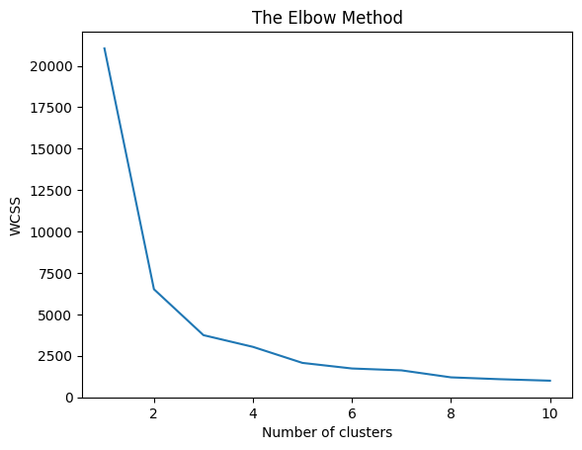

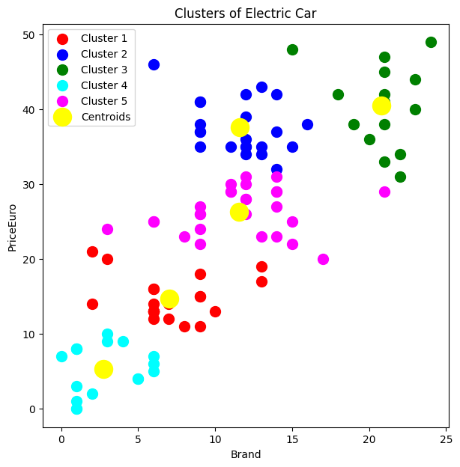

The K-Prototypes clustering algorithm was chosen as it handles both categorical and numerical data efficiently.

Optimal number of clusters was determined using the elbow method, which suggested two distinct clusters.

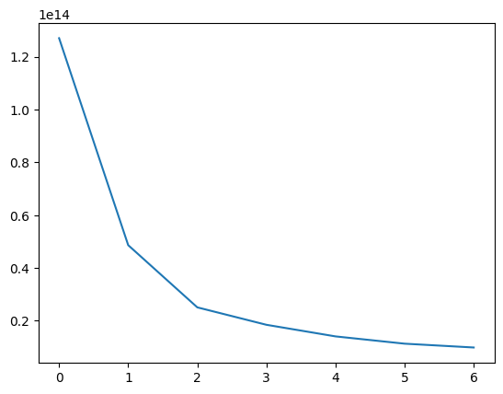

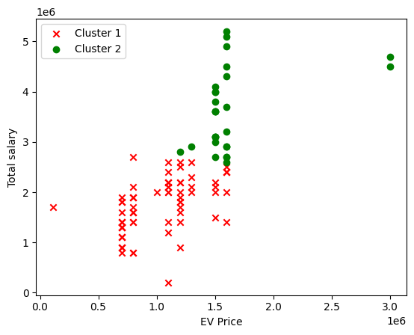

**Customer Segmentation:**

The analysis identified two customer segments:

1. **Cluster 0: Early Adopters**
   1. Younger, tech-savvy customers who are willing to pay a premium for new technology.
   2. Likely well-educated and environmentally conscious.
   3. Higher average salary and preference for premium EV models.
2. **Cluster 1: Early Majority**
   1. Middle-aged, middle-income customers who are more price-sensitive.
   2. More cautious about adopting new technology, prefer evidence of product benefits before purchasing.
   3. Interested in value-for-money options and lower-priced EV models.

How K-Prototypes Helped in Segmentation

1. Handling Mixed Data Types: The K-Prototypes algorithm effectively handled both numerical and categorical features, making it ideal for the EV market dataset, which included age, salary, and EV preferences.
2. Determining Optimal Clusters: Using the Elbow Method, the analysis determined that 2 clusters were most suitable, categorizing customers into Early Adopters and Early Majority segments.
3. Segment Insights: The algorithm provided clear distinctions between clusters, highlighting that Early Adopters prefer premium, higher-priced EV models, while the Early Majority is more price-sensitive and opts for budget-friendly options.
4. Visualization of Clusters: Scatter plots and 3D visualizations helped illustrate the separation between clusters, offering insights into how factors like salary and age influence customer preferences.

**Exploratory Data Analysis (EDA)**

**Distribution of Numeric Attributes**

This density plot analysis visualizes the distribution of each numeric attribute in the dataset, providing insights into their spread and central tendency. The Kernel Density Estimation (KDE) plots indicate that some features have a normal distribution (e.g., price, battery capacity), while others exhibit skewness or multimodal patterns. The analysis helps identify potential outliers and understand the overall data shape, which is essential for feature scaling and model selection.

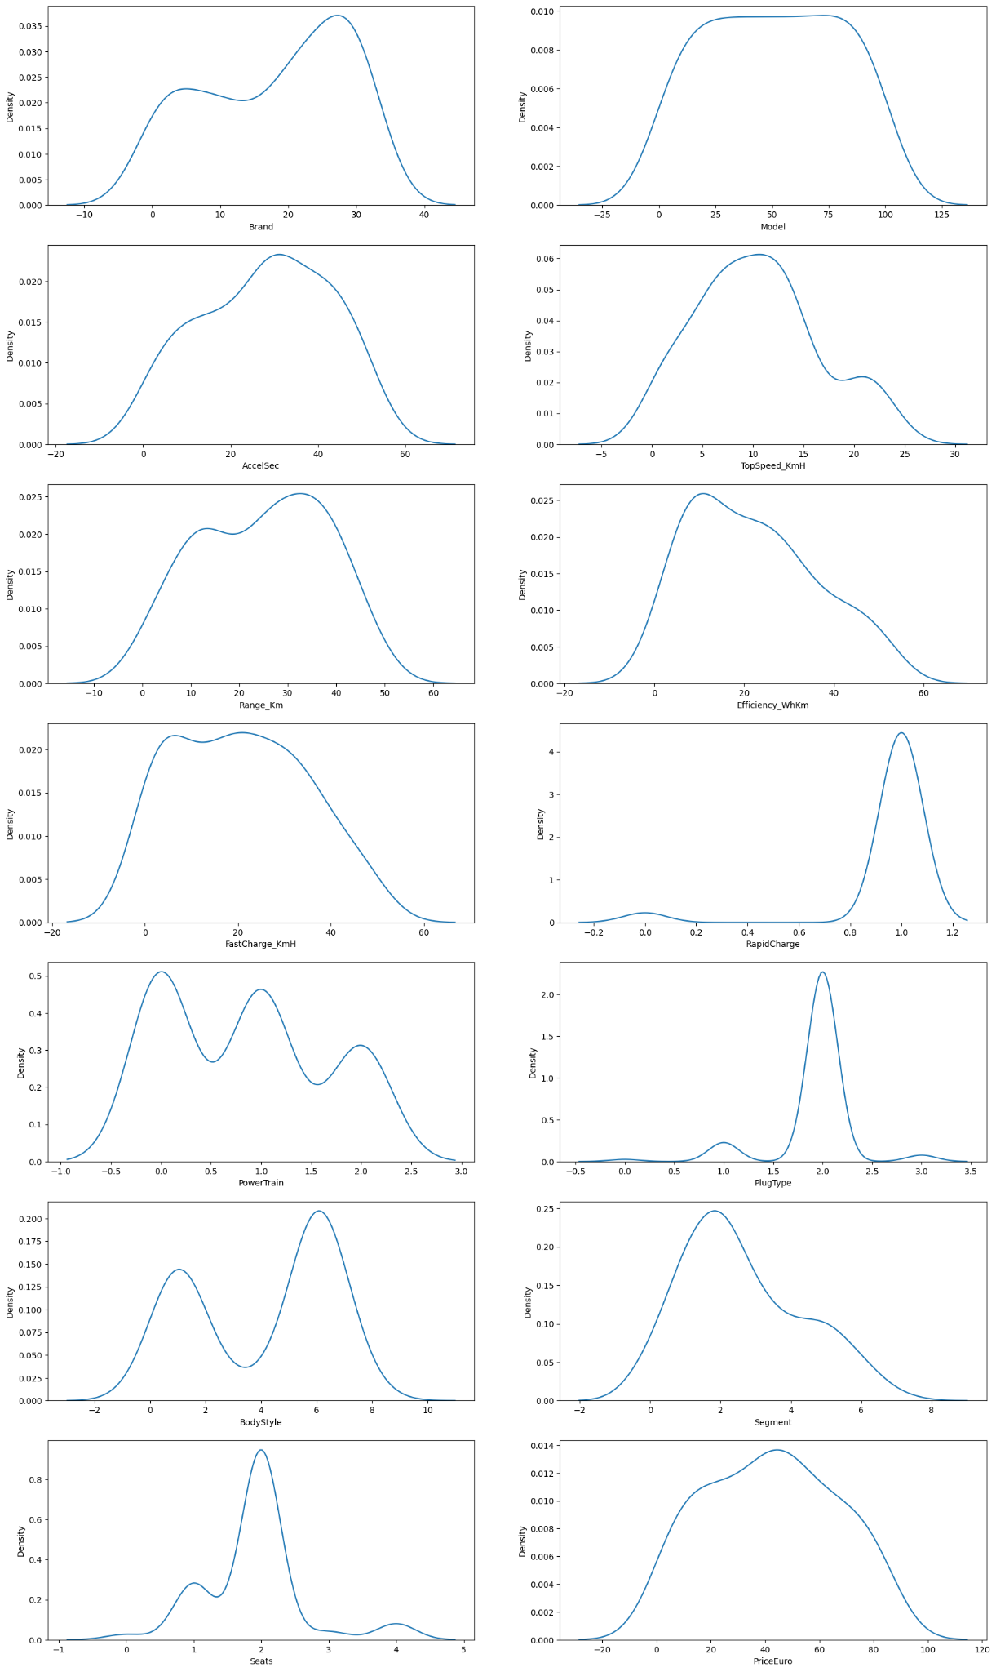

**Frequency of EV Brands in the Dataset**

The dataset showcases the frequency of various EV brands, with Ather Energy, Bajaj, and TVS emerging as the most common brands. These three brands dominate the dataset, reflecting their significant presence in the Indian EV market. The rest of the brands have a relatively lower frequency, indicating their smaller share in the dataset.

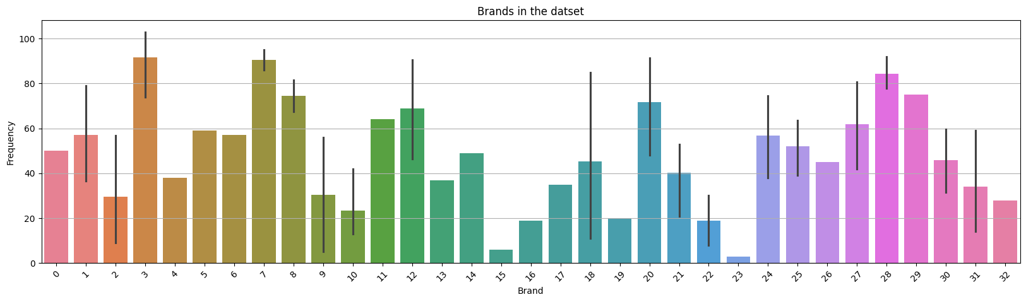

**Seat Capacity Distribution Across EV Brands**

The plot shows the number of seats in various EV models, highlighting differences across brands. Most brands offer models with 2 to 5 seats, with some manufacturers providing a wider range of seating capacities. The data indicates that EV brands cater to both compact and larger vehicle segments.

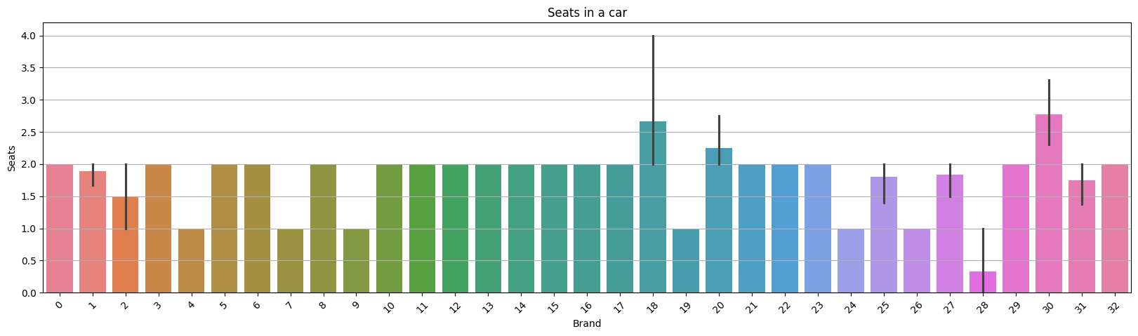

**Top Speed Performance by EV Brand**

The plot reveals the top speeds of different EV brands, with notable speed differences between brands. Some brands like Ather Energy, Bajaj, and Hero Electric exhibit higher top speeds, indicating a focus on performance, while other brands tend to offer more moderate speeds.

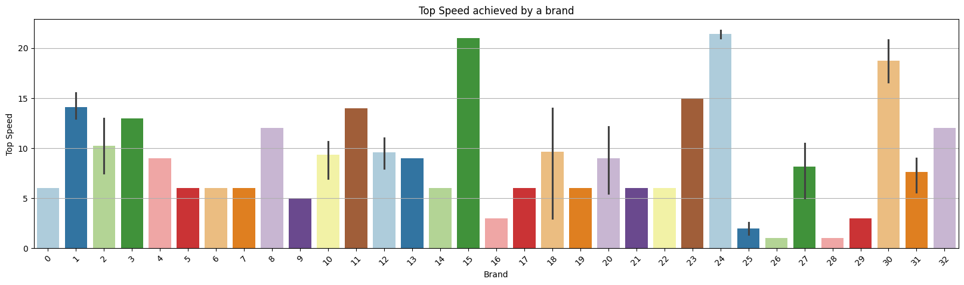

**Distribution of Plug Types Used for EV Charging**

The pie chart shows the distribution of different plug types used for charging EVs. It reveals the most commonly used plug type, highlighting a preference for specific connectors in the market.

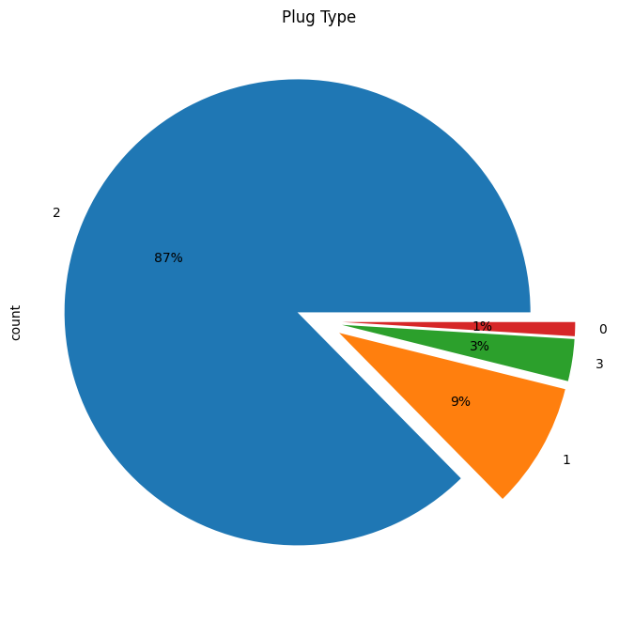

**Age Distribution Analysis**

The age distribution of customers shows a peak between 20 and 40 years, with a slight right skew towards older age groups. Most customers are in the younger to mid-adult range, indicating a strong interest in EVs from these demographics. Older customers still represent a significant portion, suggesting broad appeal.

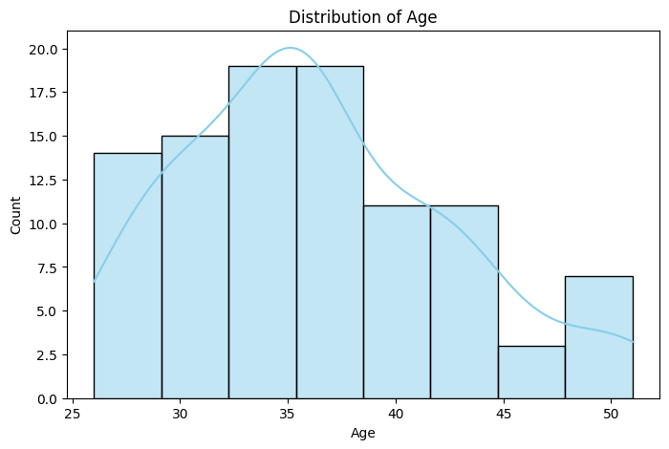

**Customer Count by Profession**

The majority of customers belong to professions such as engineers, professionals, and business owners, indicating a higher preference for EVs among individuals in technical and entrepreneurial roles. Other professions like students and teachers also show considerable interest, reflecting a diverse customer base. The distribution highlights a clear trend towards educated and financially stable segments.

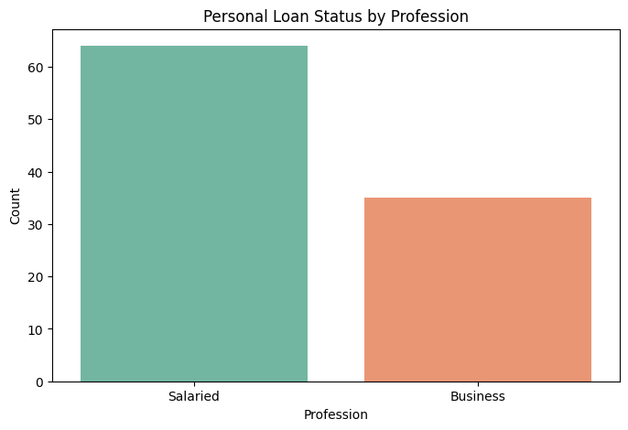

**Car Loan Status by Marital Status**

The plot reveals that married individuals have a higher likelihood of taking a car loan compared to singles. Among married customers, a significant proportion have car loans, suggesting a trend of financial commitments. Singles show a relatively lower car loan uptake, which could indicate a preference for fewer financial obligations.

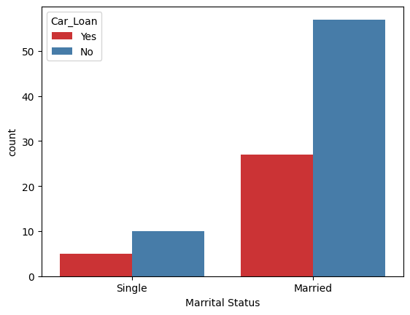

**Correlation matrix for the features in one of the dataset used.**

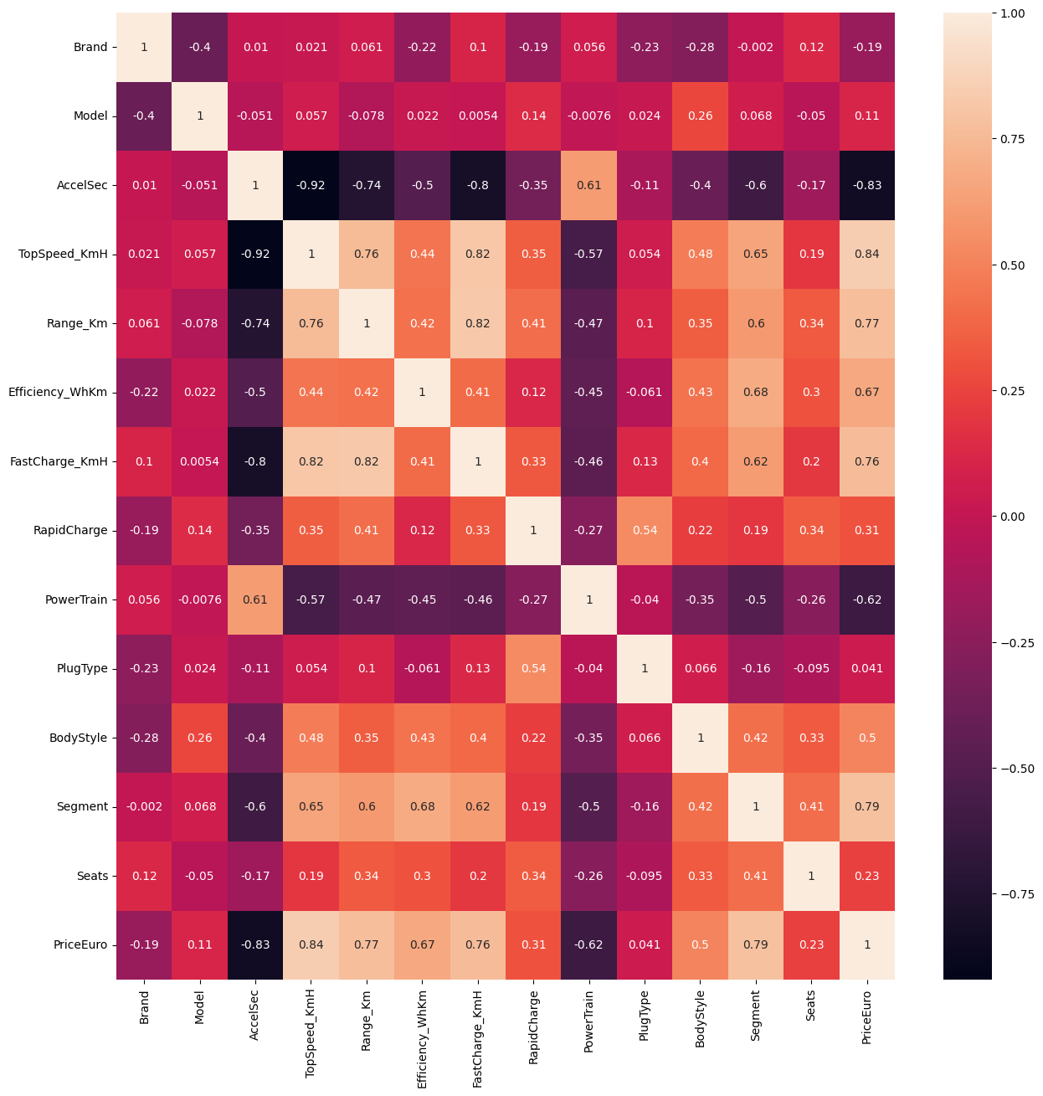

### **Final Conclusion & Insights Gained**

Key Insights from Segmentation Analysis

1. **Distinct Customer Segments Identified:** The analysis segmented customers into two main groups—Early Adopters and Early Majority—providing a clearer understanding of market dynamics.
2. **Preference for Budget-Friendly EVs:** The majority of the Early Majority segment preferred budget-friendly EV options, emphasizing the importance of competitive pricing in capturing this segment.
3. **Demand for Premium Features Among Early Adopters:** Early Adopters showed a tendency towards higher-end EV models, valuing advanced features such as extended battery range and faster charging times.
4. **Diverse Regional Adoption Trends:** Adoption varied significantly by region, with urban areas displaying higher adoption rates due to better infrastructure and awareness, especially in states like Maharashtra and Karnataka.

**Segment Extraction**

**K-Prototypes Clustering**  
Using K-Prototypes clustering, we identified two distinct customer segments:

1. **Early Adopters:** This group comprises younger, tech-savvy individuals who are willing to pay a premium for new EV technology, with a higher income and a preference for advanced features.
2. **Early Majority:** This segment consists of middle-aged, middle-income individuals who are more price-sensitive and tend to adopt technology after it becomes mainstream.

**Key Insights**

Target Customer Segments  
• **Early Adopters:** A younger, environmentally conscious group willing to pay more for cutting-edge EV technology.  
• **Early Majority:** More price-conscious customers, likely to purchase EVs once they have been proven in the market.

Pricing Strategy  
• **Early Adopters:** Focus on premium pricing and advanced technology, targeting tech-driven cities.  
• **Early Majority:** Offer more affordable EV options with value-driven propositions for a broader audience.

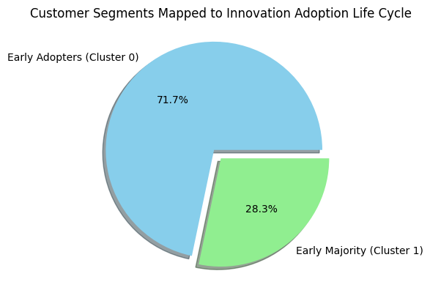

**Conclusion**

The segmentation reveals two clear groups with distinct preferences and financial capabilities. The Early Adopters are focused on innovation, while the Early Majority looks for cost-effective, practical solutions. Tailored marketing strategies should address these differences to maximize customer engagement. The Silhouette Score of 0.55 indicates a reasonable level of cluster separation, though further refinement may enhance accuracy.

In conclusion, electric vehicles are the future hence - ***“Go Green Go Electric”.***